Living Wage Scotland 2024 Award – Local Champion |  | 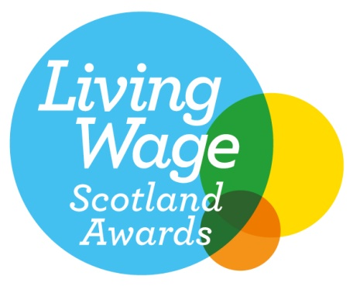
We are delighted you have decided to apply for the Living Wage Scotland 2024 Local Champion Award. This award is open to Accredited employers of any size, who can demonstrate positive impact within their local community.

Criteria: An employer who has shown continued commitment to the Living Wage movement through their actions and behaviours.

Any questions, please feel free to e-mail anna.hirvonen@povertyalliance.org

Your Contact Information
Your Full Name
Your Employer’s Name
Your Job Title
Your Department
Address
City / Town
Region
Postcode
E mail address
Phone number
Question 1: Tell us about the actions and behaviours you feel have demonstrated your commitment to the Living Wage movement? (maximum 300 words)

Question 2: How do you support and engage with your local community? (maximum 300 words)
Question 3: Why has your organisation chosen to demonstrate this commitment to the real Living Wage? (maximum 300 words)
Please complete and return by Friday 30th August 2024. Applications received after the deadline will not be accepted.

The winners of this year’s Living Wage Scotland Awards will be announced during Living Wage Week at our Awards ceremony held on the 7th November in Glasgow.

