Living Wage Scotland 2024 Award – Outstanding Leadership |  | 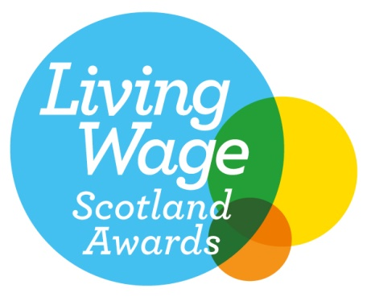
We are delighted you have decided to apply for the Living Wage Scotland 2024 Outstanding Leadership Award which is open to accredited employers of any size.

Criteria: An employer who consistently demonstrates leadership through actions such as: working to encourage others to become accredited as Living Wage employers, speaking out publicly on the real Living Wage, and going above and beyond the scope of the accreditation licence criteria.

Any questions, please feel free to e-mail anna.hirvonen@povertyalliance.org

Your Contact Information
Your Full Name
Your Employer’s Name
Your Job Title
Your Department
Address
City / Town
Region
Postcode
E mail address
Phone number
Question 1: How has your organisation demonstrated leadership and what has been the impact of this? (maximum 300 words)
Question 2: How have you gone above and beyond your Living Wage commitment? (maximum 300 words)
Question 3: Why has your organisation chosen to demonstrate a commitment to the real Living Wage? (maximum 300 words)
Please complete and return by Friday 30th August 2024. Applications received after the deadline will not be accepted.

The winners of this year’s Living Wage Scotland Awards will be announced as part of Living Wage Week at our Awards ceremony held on the 7th November in Glasgow.

