Living Wage Scotland 2024 Award – Voice of the Year |  | 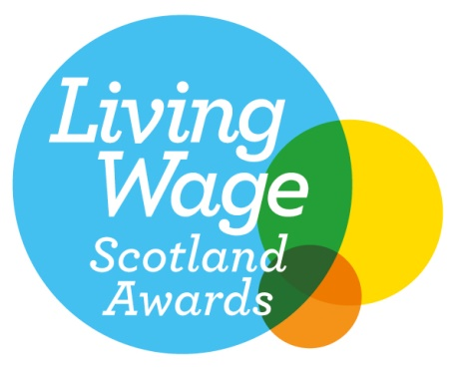
We are delighted you have decided to apply for the Living Wage Scotland 2024 Voice of the Year Award. This award recognises workers and individuals of Living Wage accredited employers who have positively contributed to the Living Wage movement by for example speaking about the Living Wage at events, in the media, or by spreading the Living Wage message among their networks.

Criteria: Individuals who stand out in their commitment and advocacy for the Living Wage. Someone who has made a positive contribution to the movement by encouraging others to accredit, by speaking out about the benefits of the Living Wage in the media, or who actively participates in Living Wage activities. The application should point to specific actions or activities.
Any questions, please feel free to e-mail anna.hirvonen@povertyalliance.org

Your Contact Information
Your Full Name
Your Employer’s Name
Your Job Title
Your Department
Address
City / Town
Region
Postcode
E mail address
Phone number
Question 1: Tell us about actions and activities you have undertaken that have positively contributed to the Living Wage movement? (maximum 300 words)
Question 2: What has been the impact of this activity? (maximum 300 words)
Question 3: Why have you chosen to support the Living Wage movement? (maximum 300 words)
Please complete and return by Friday 30th August 2024. Applications received after the deadline will not be accepted.

The winners of this year’s Living Wage Scotland Awards will be announced during Living Wage Week at our Awards ceremony held on the 7th November in Glasgow.

